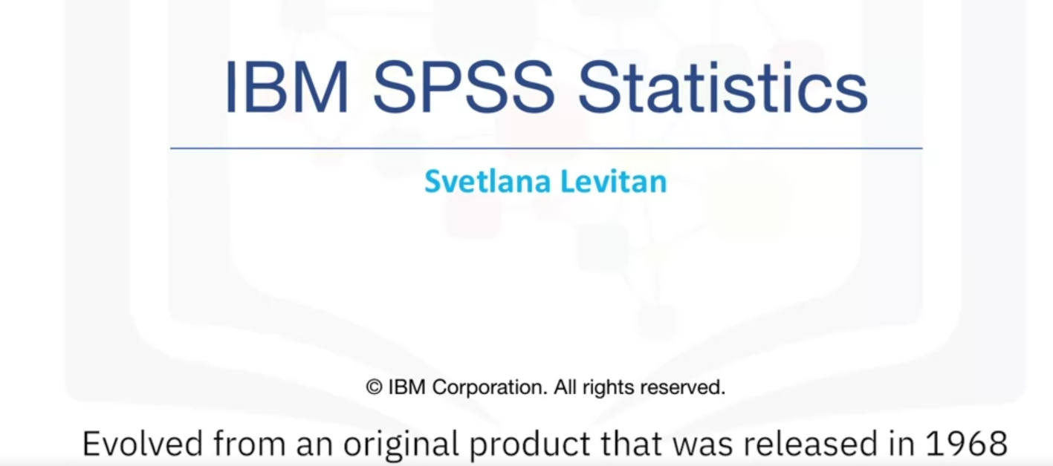

Statistical package for social sciences.

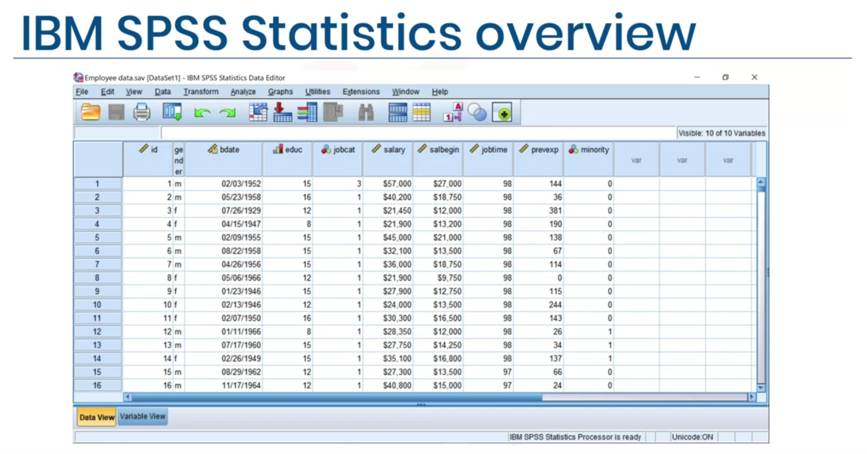



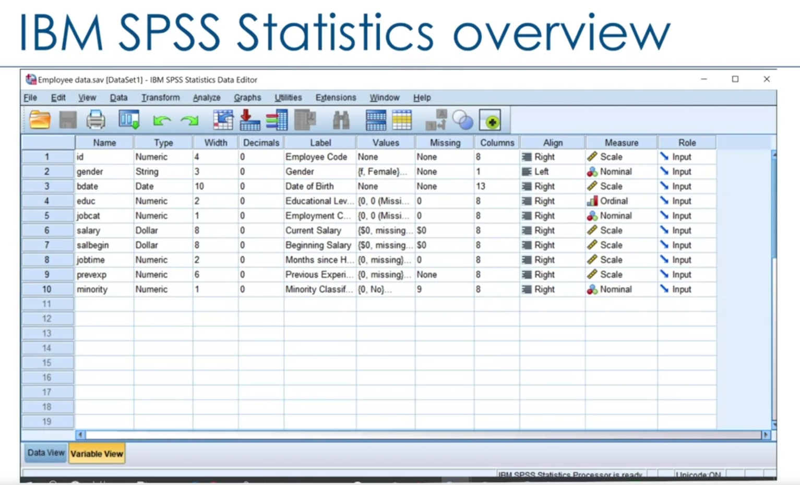

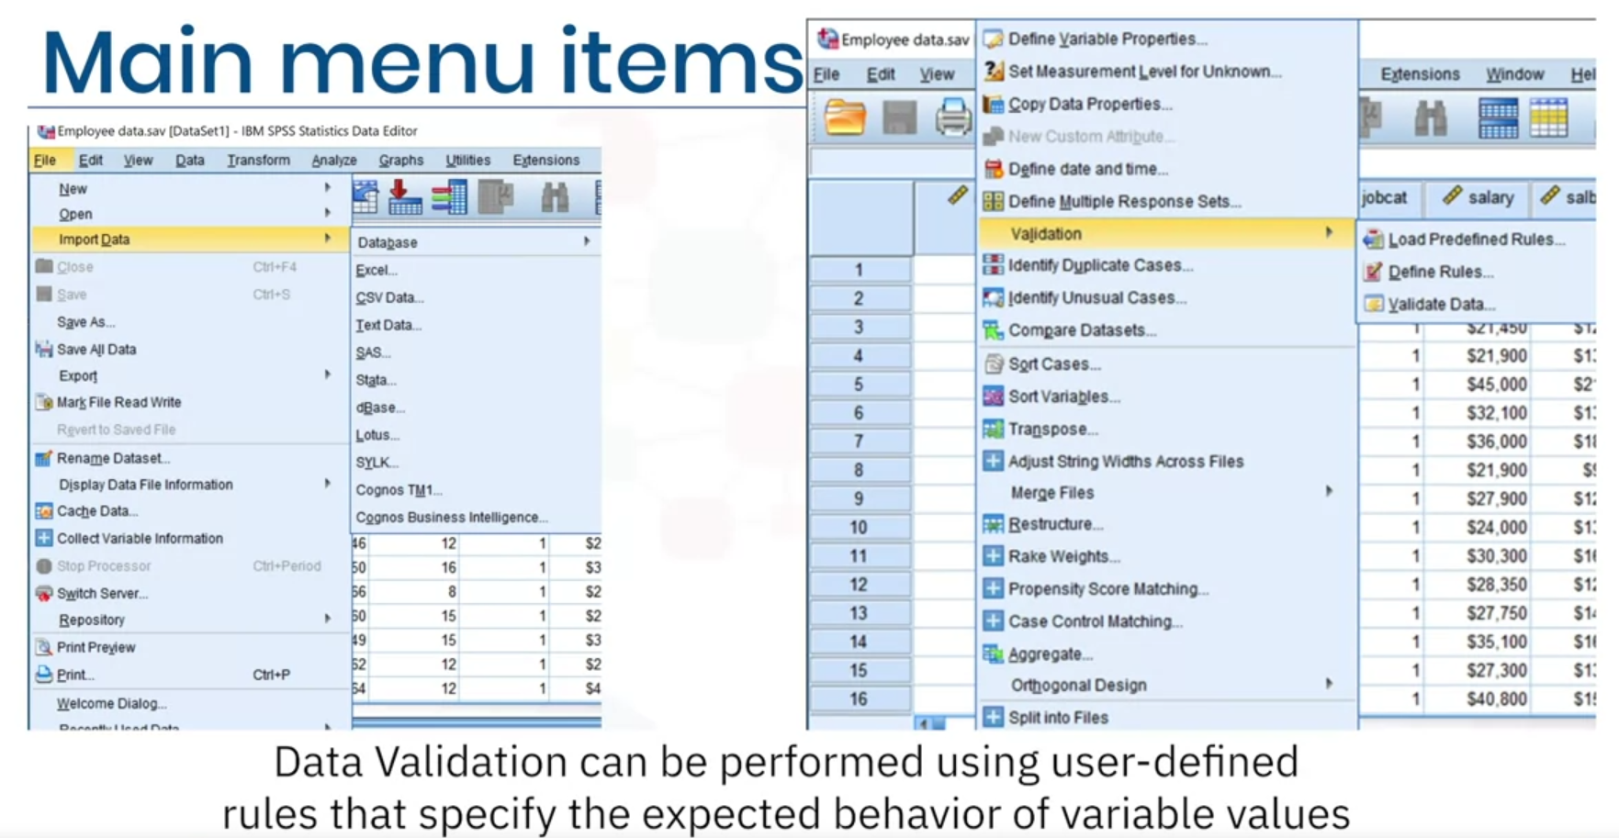

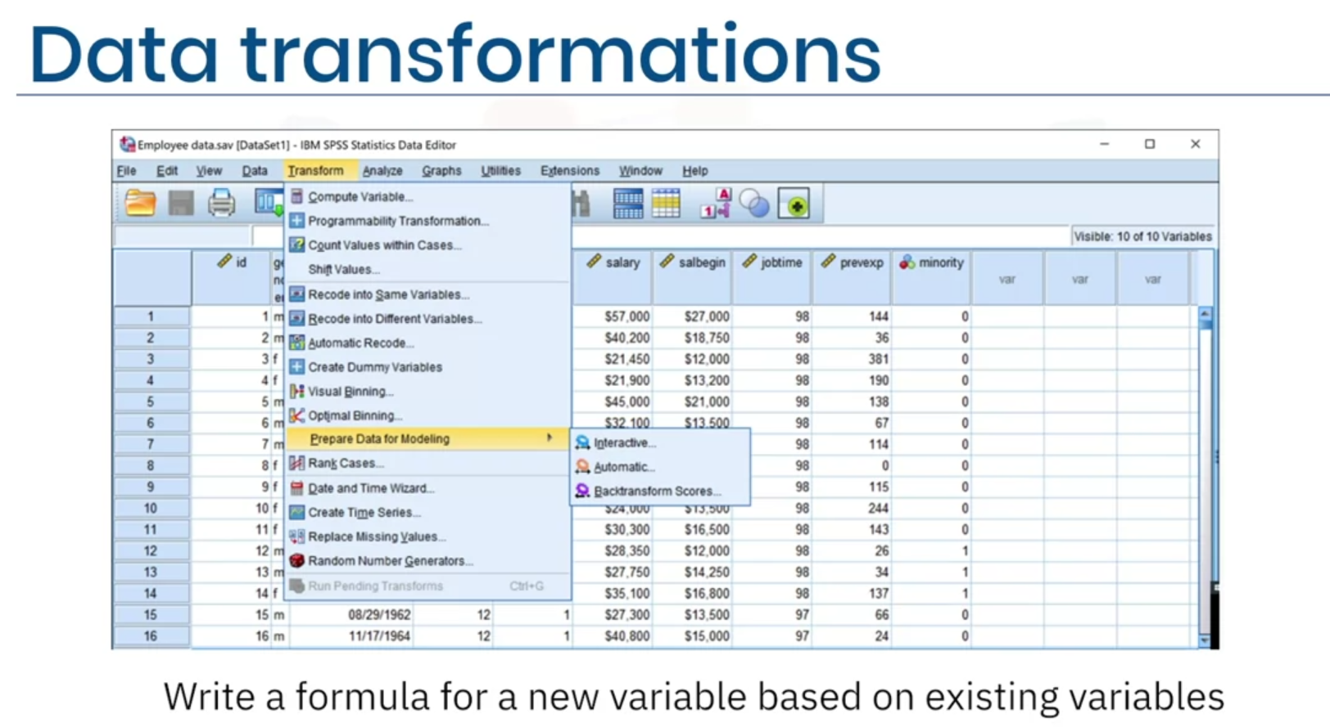

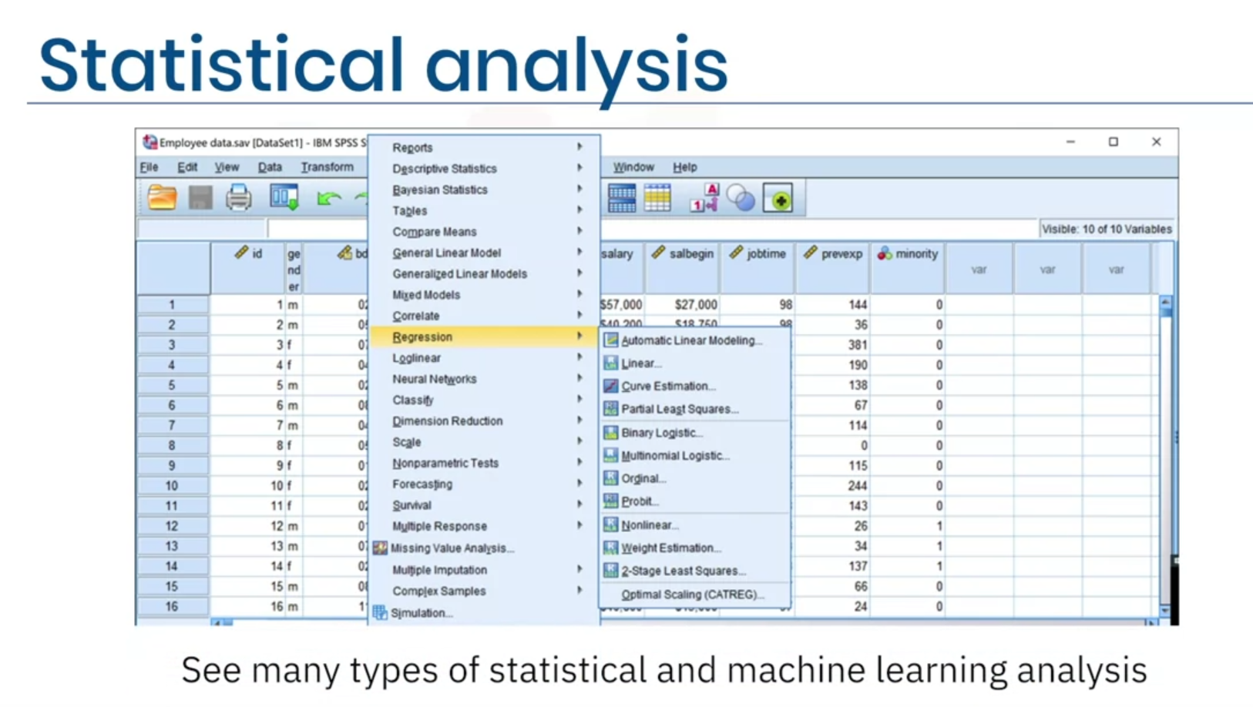

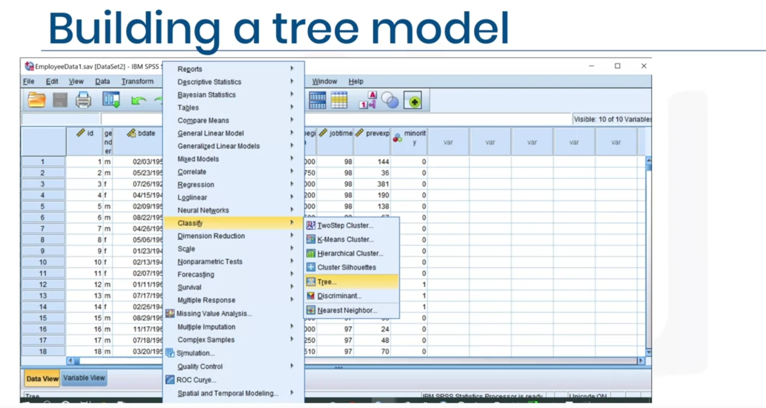

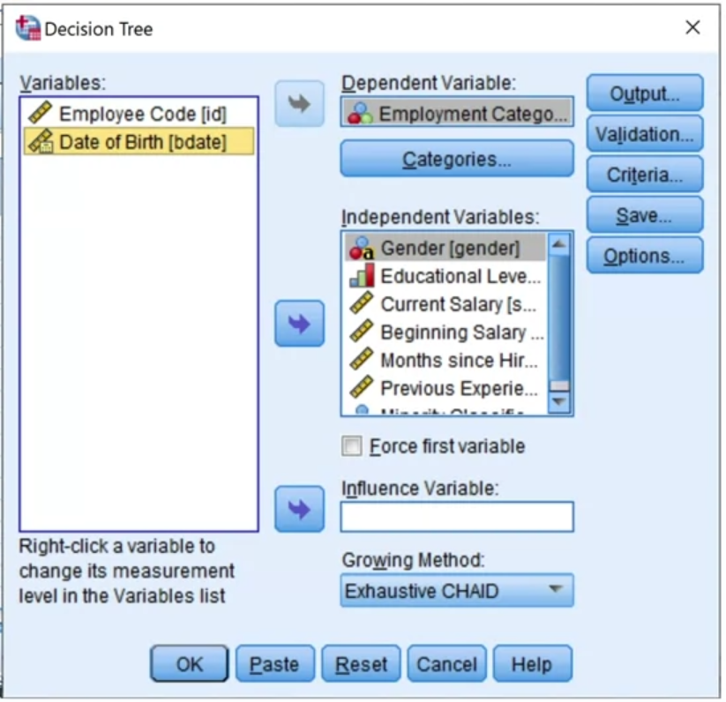

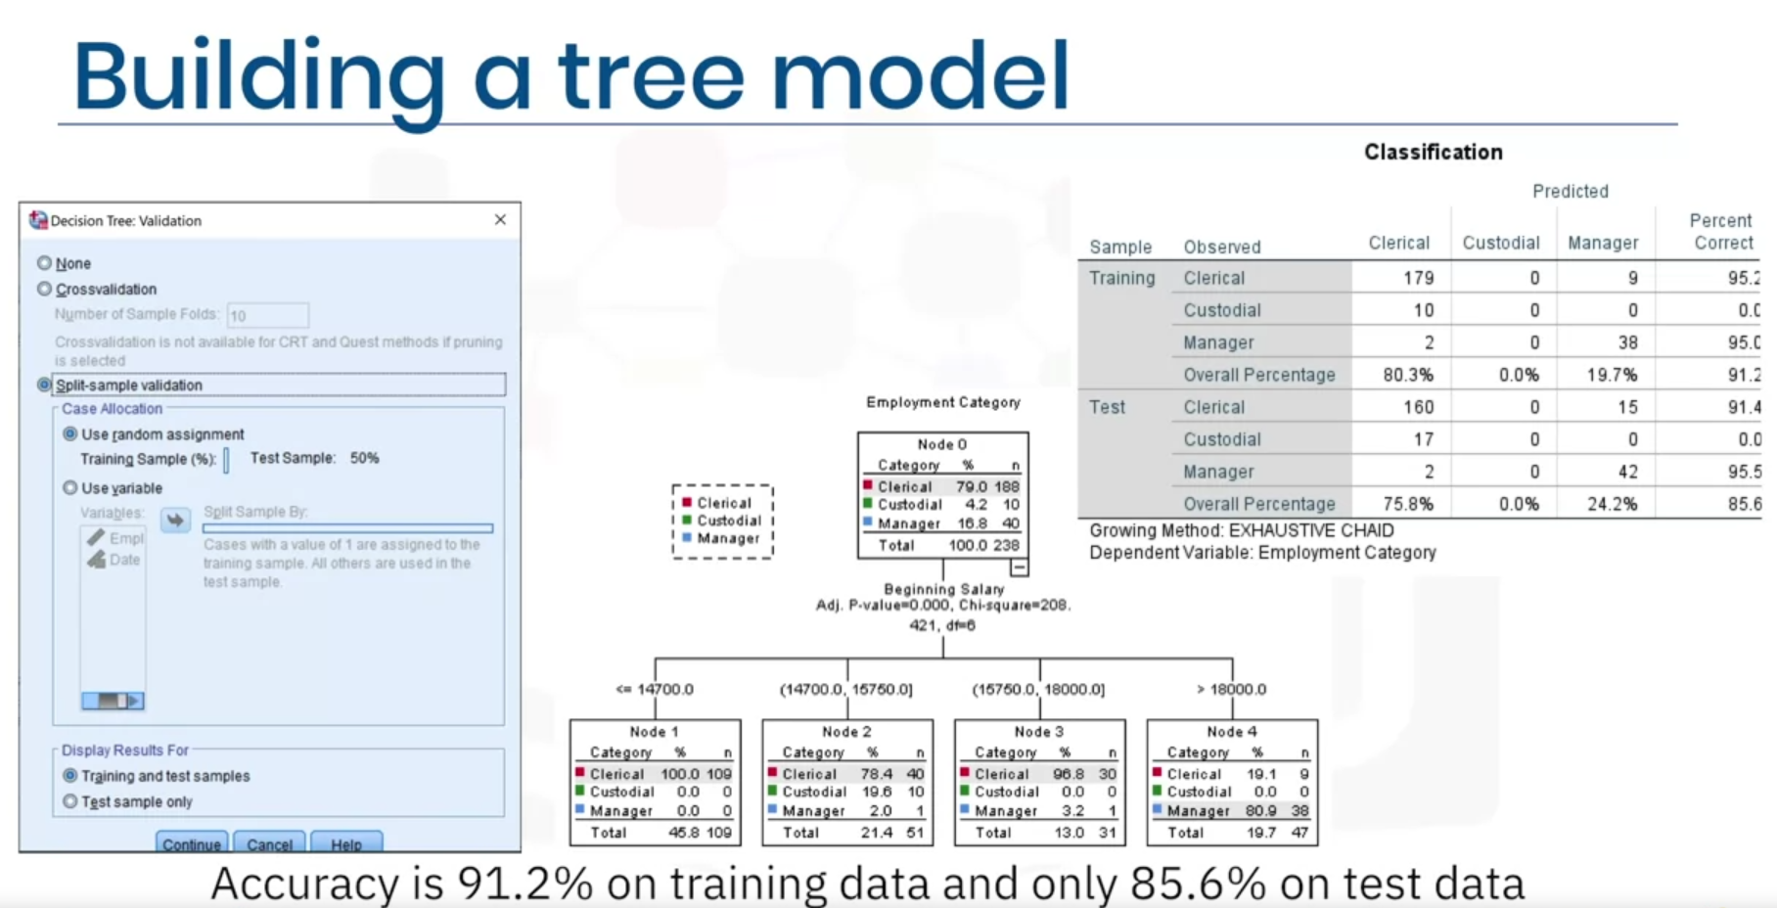

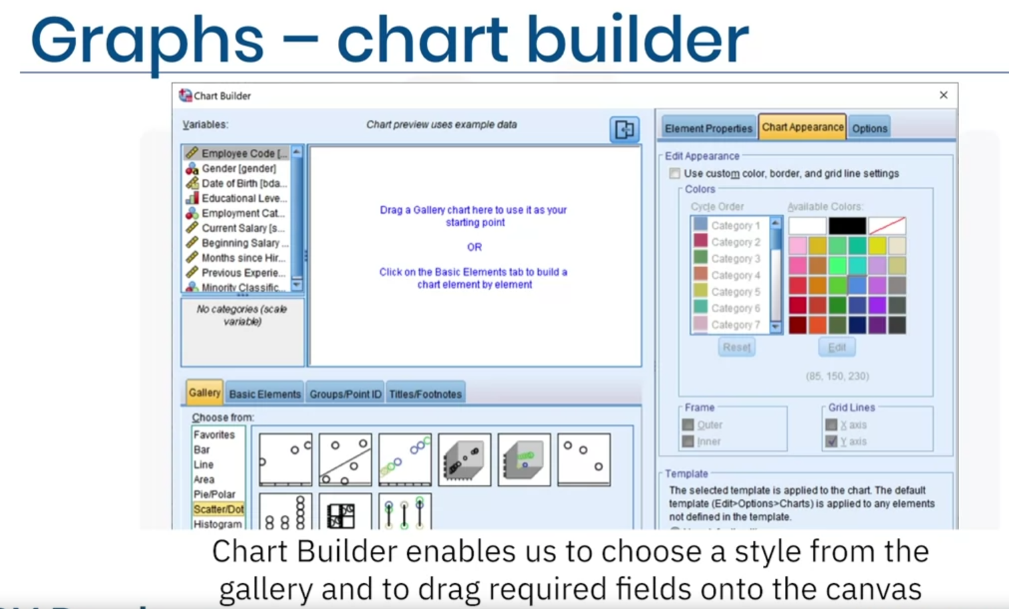

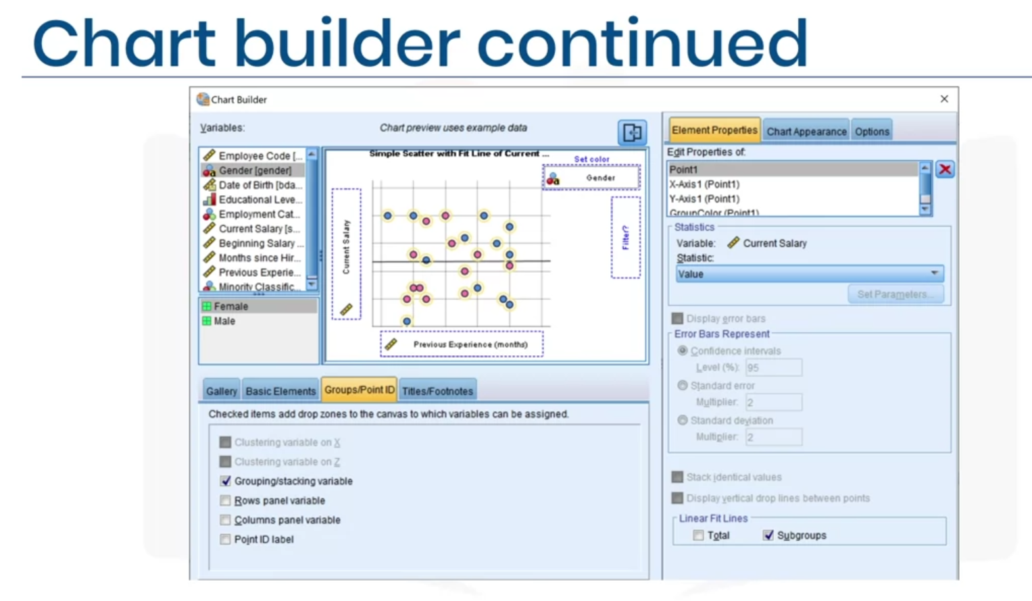

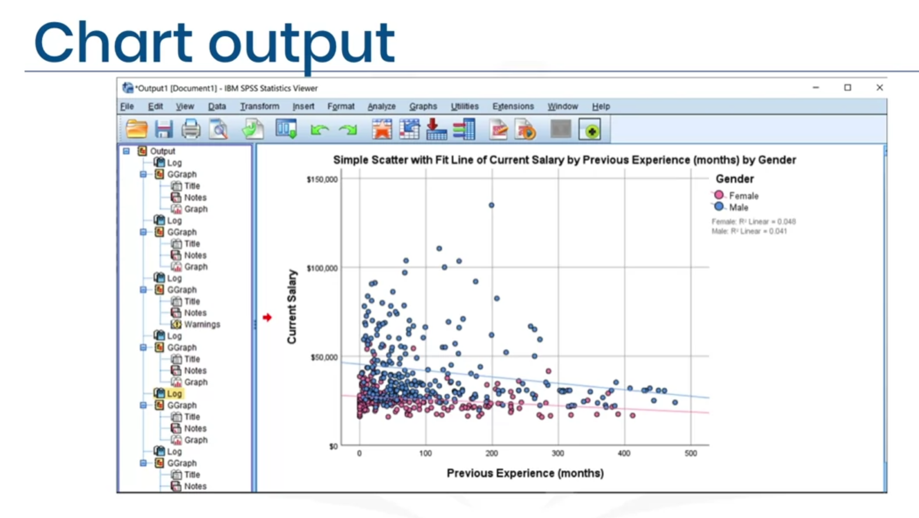

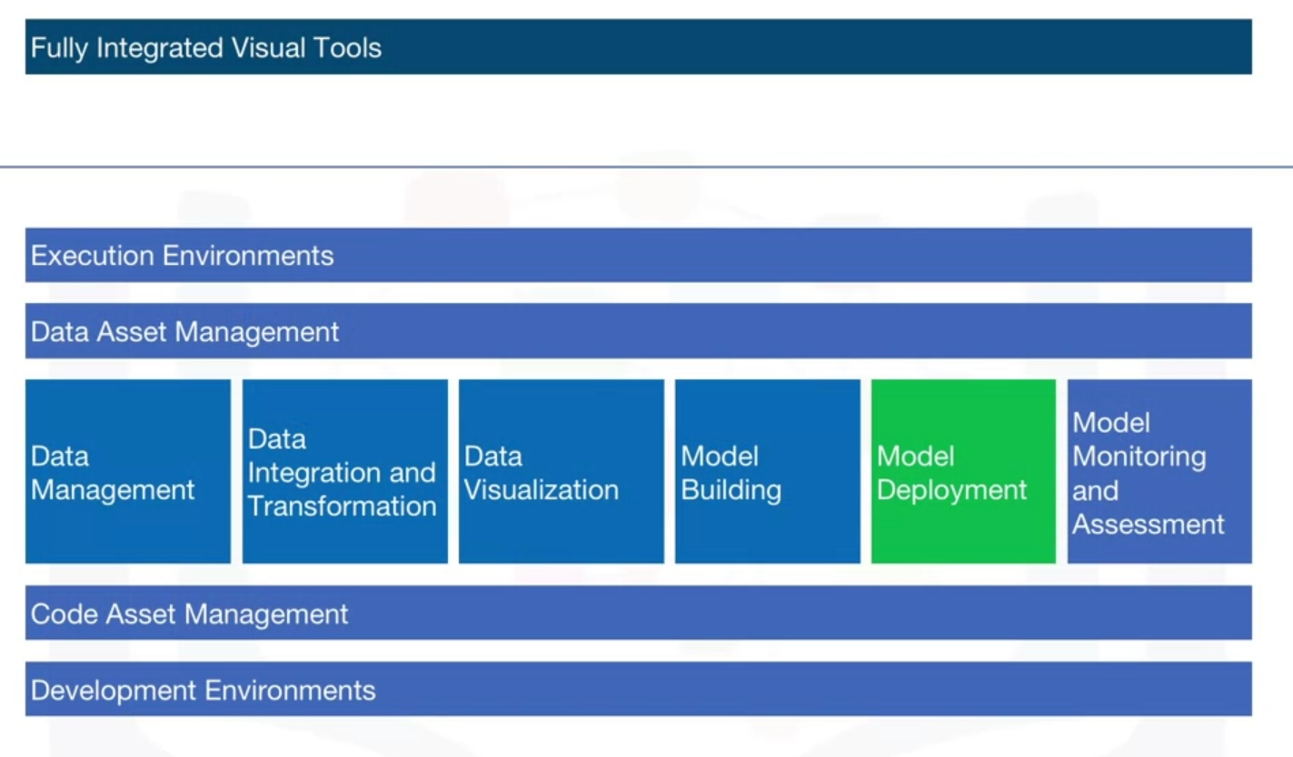

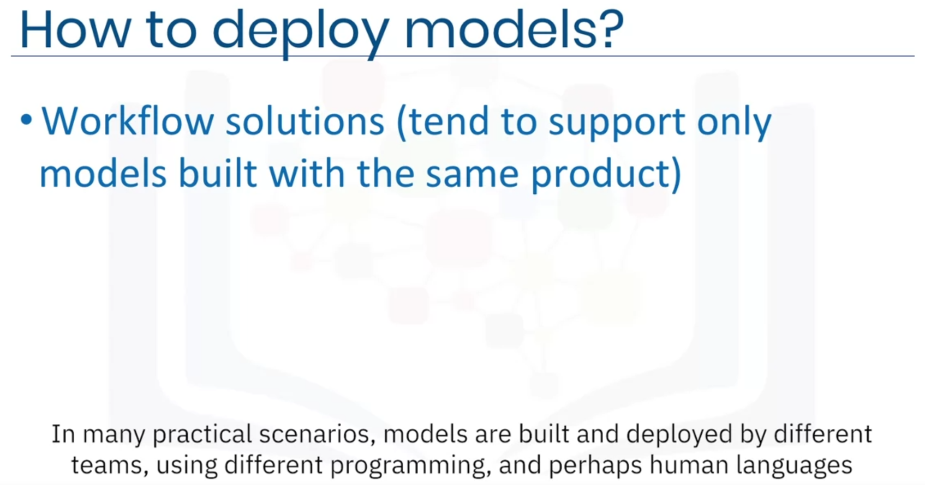

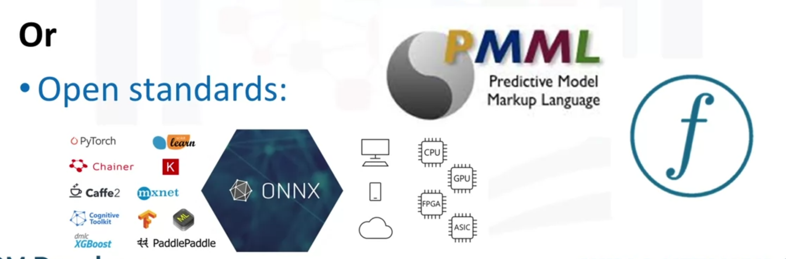

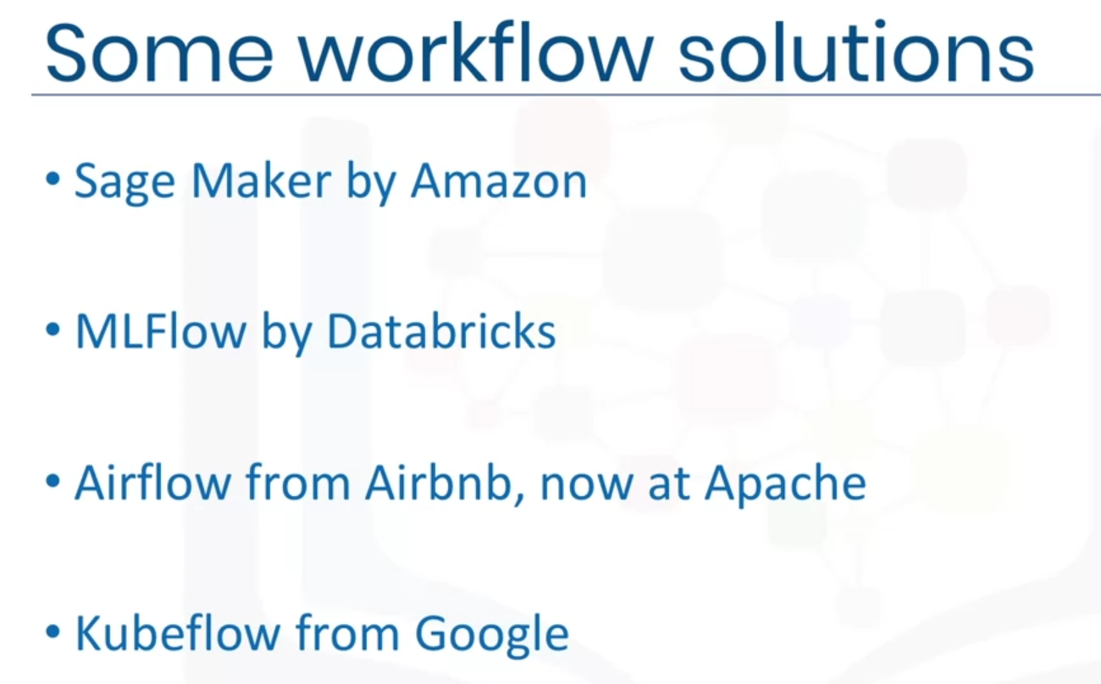

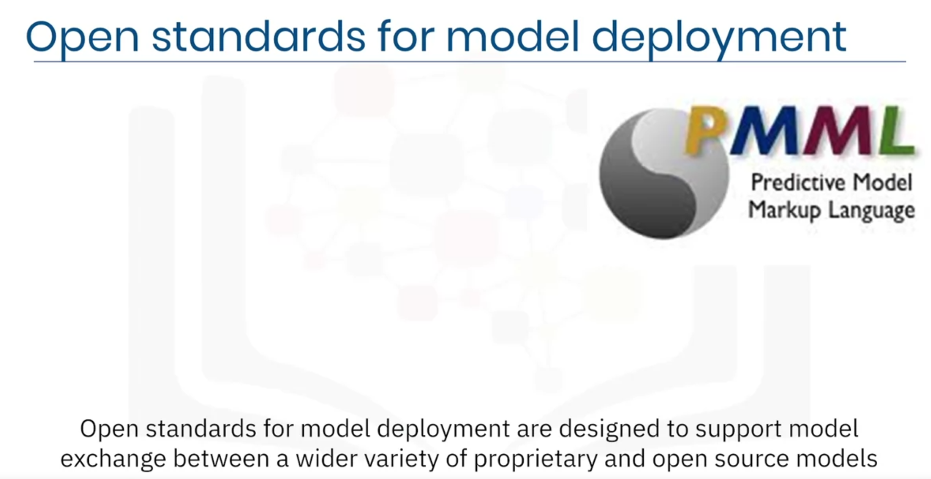

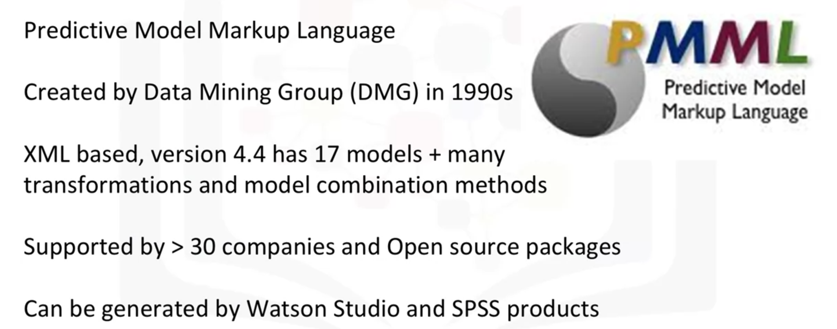

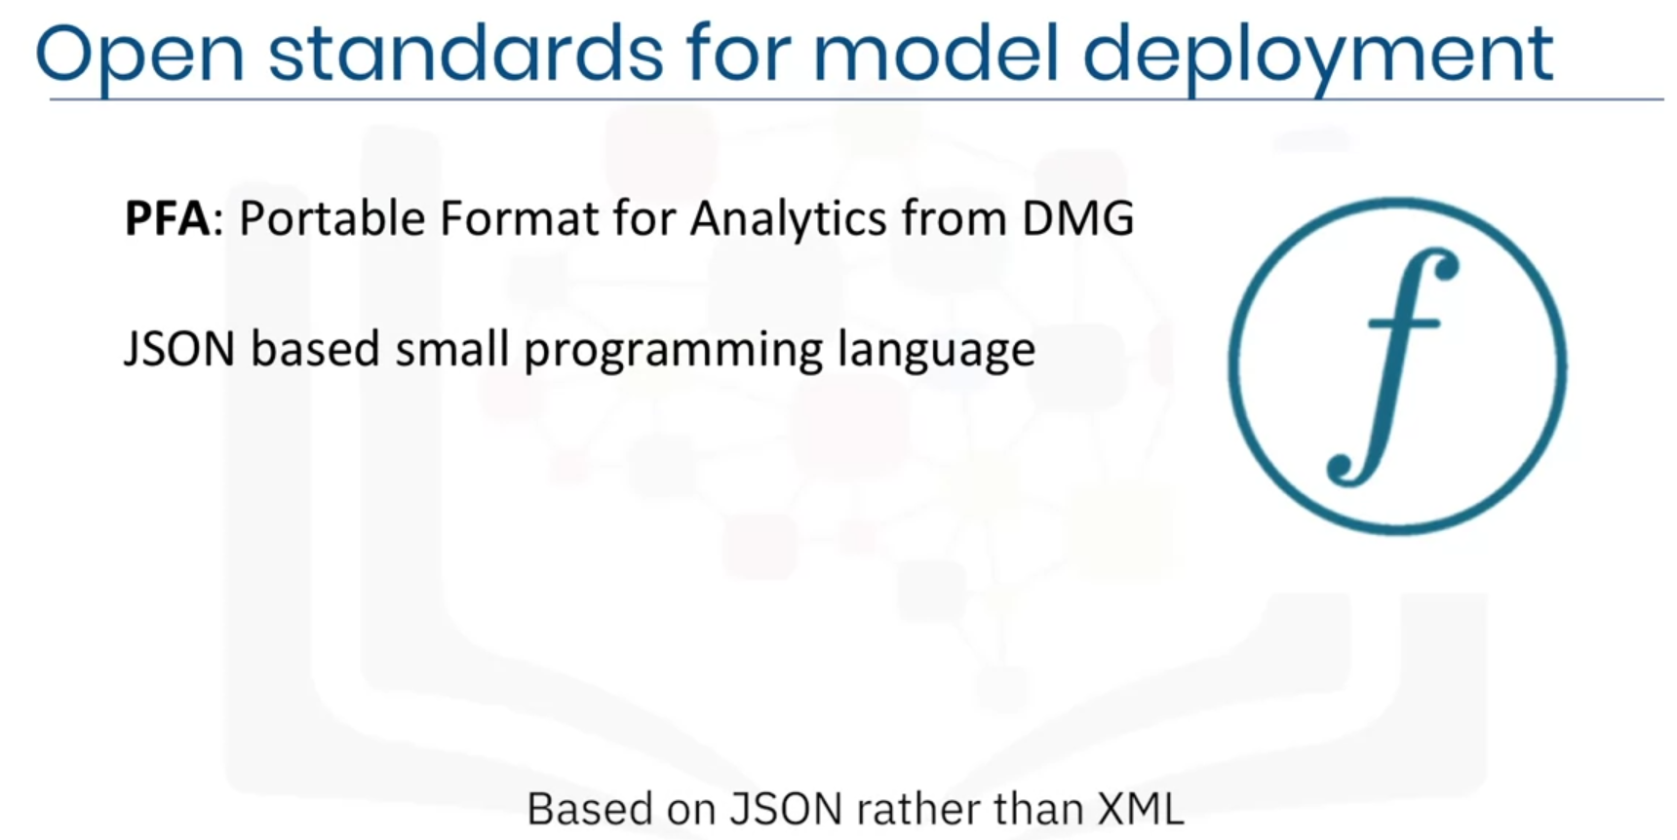





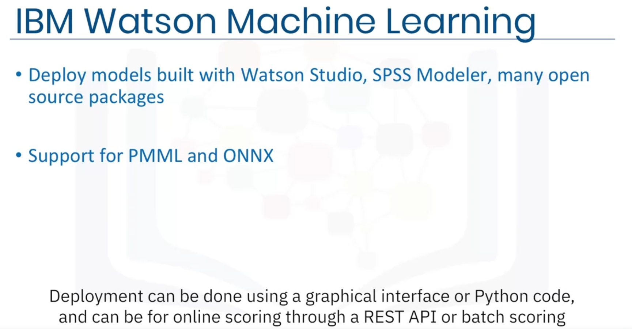



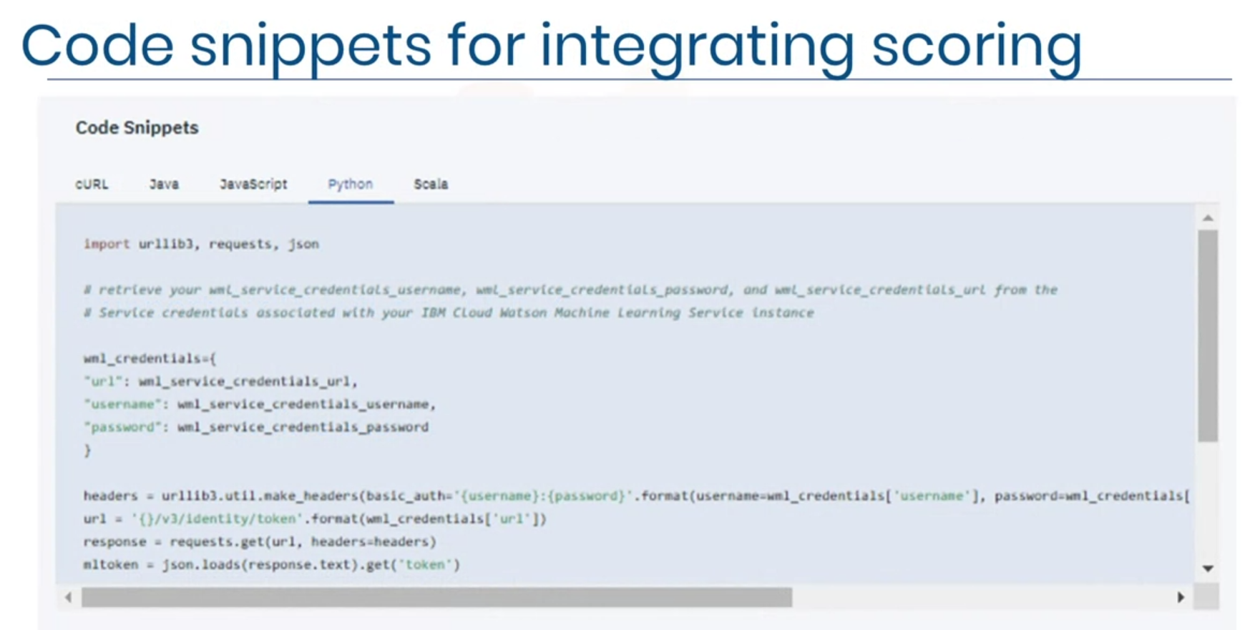



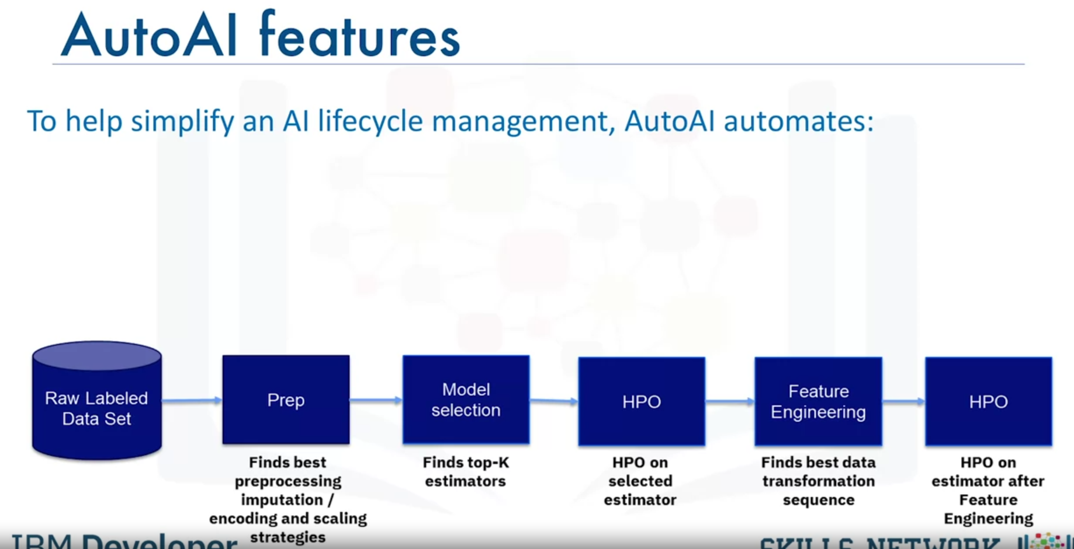



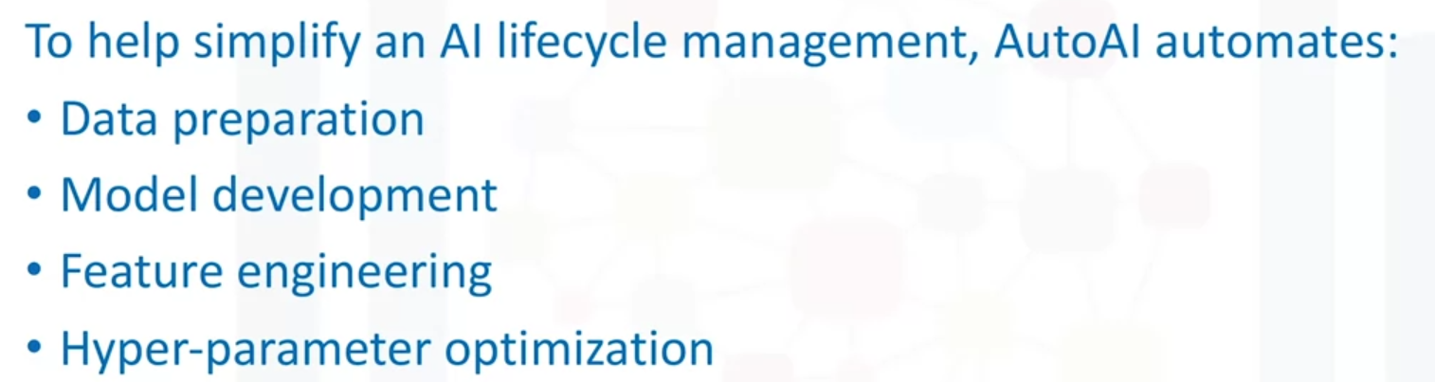

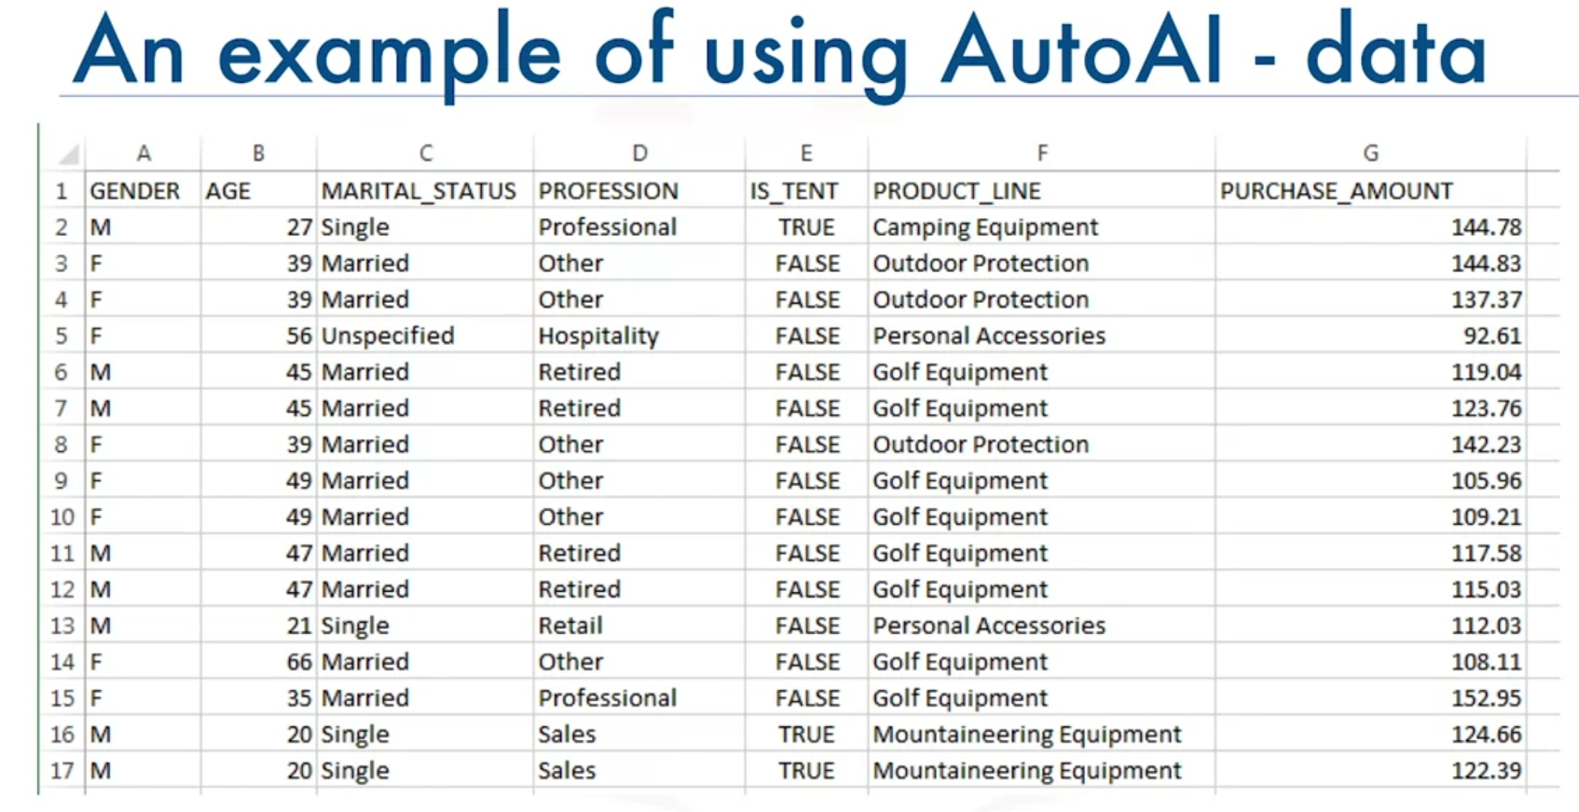

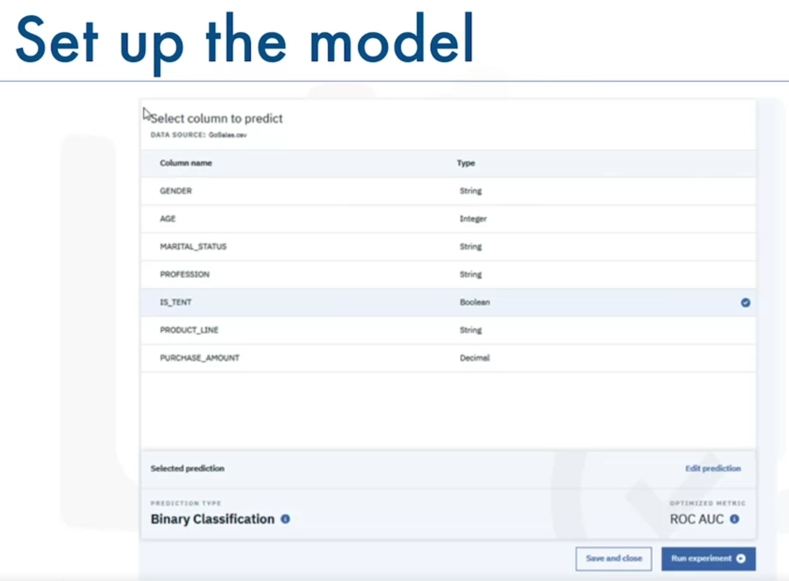

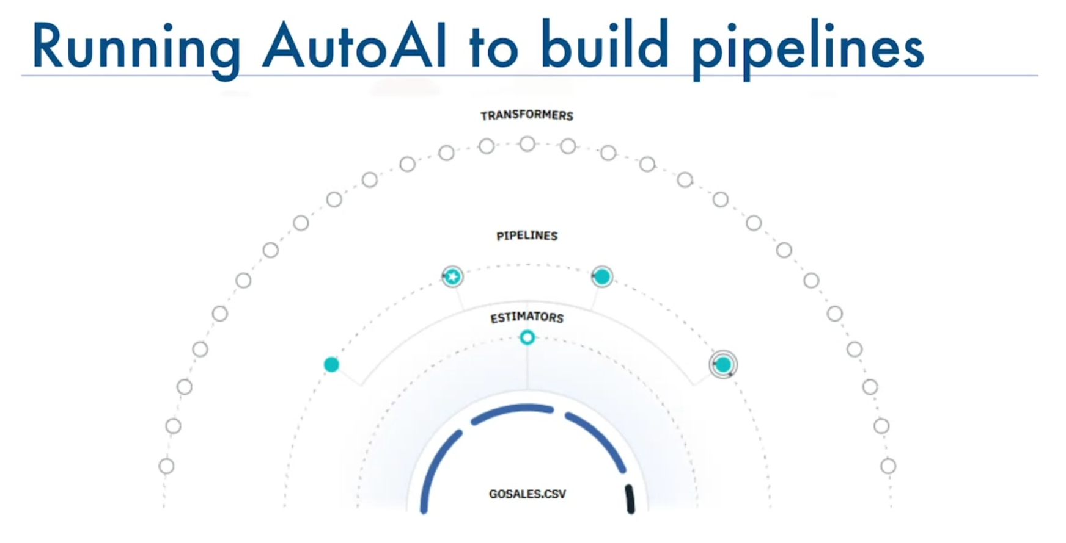

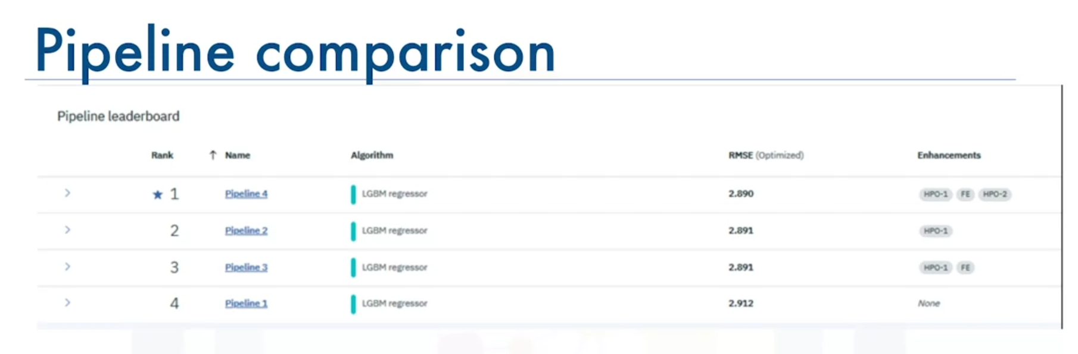

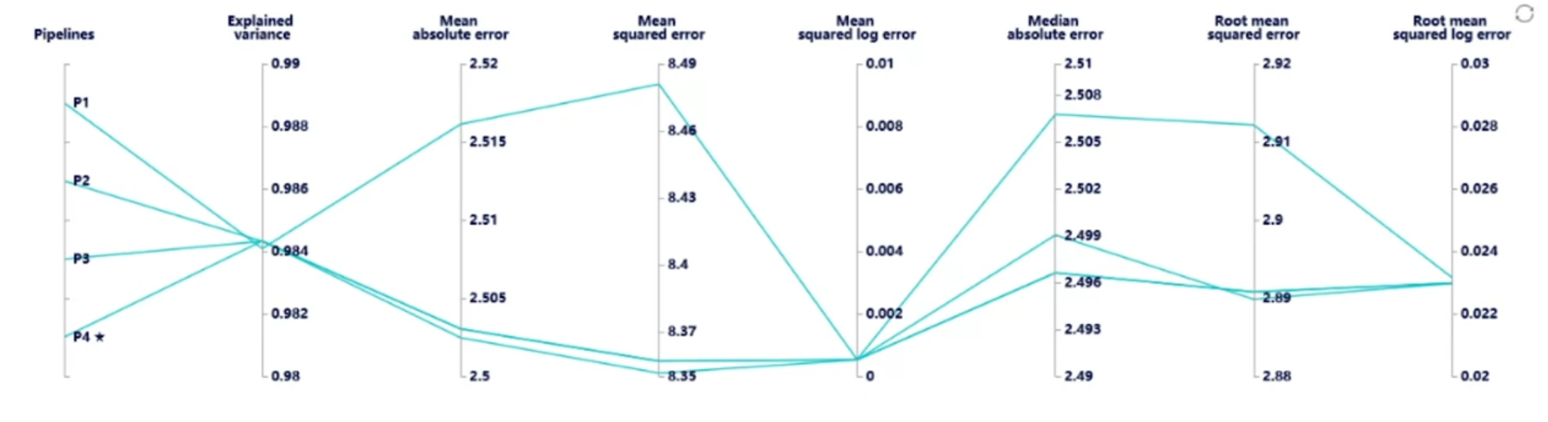



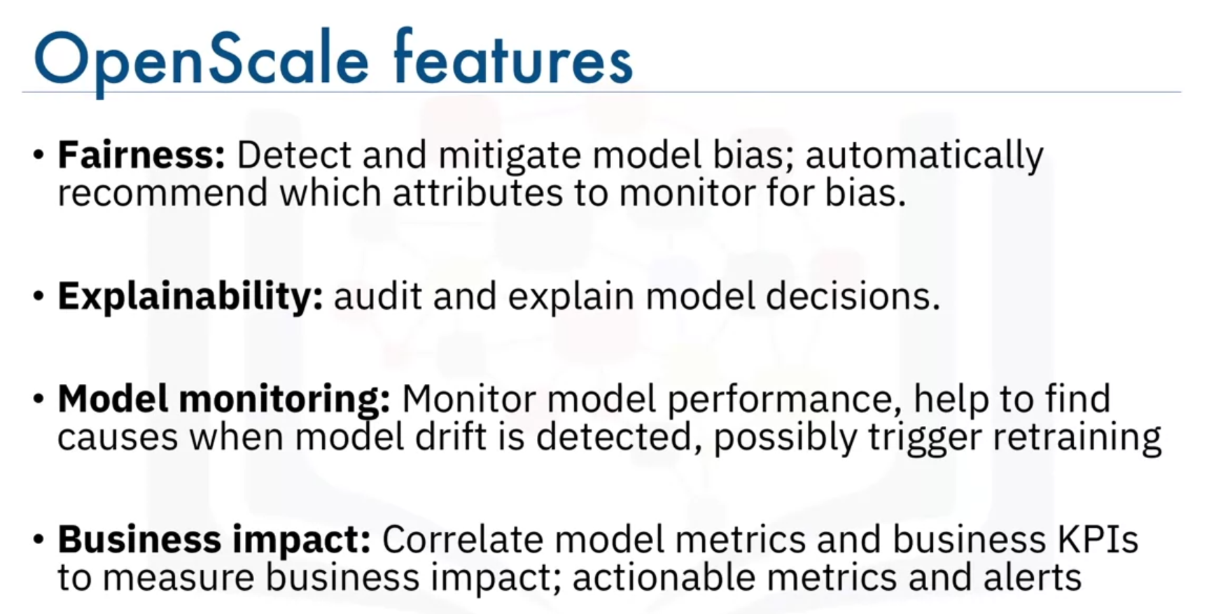

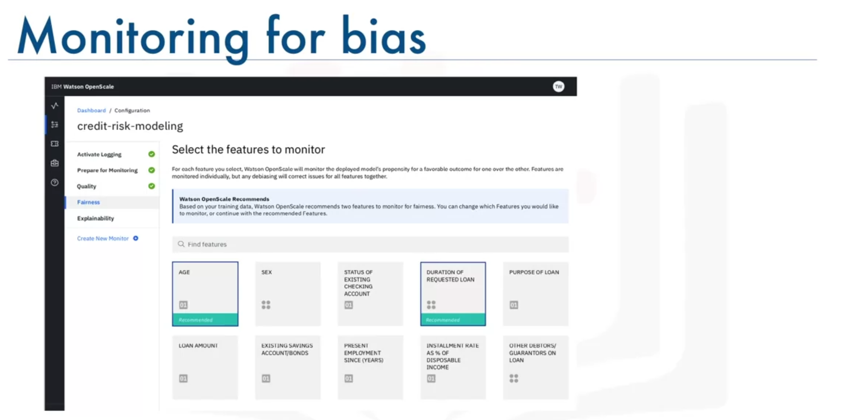

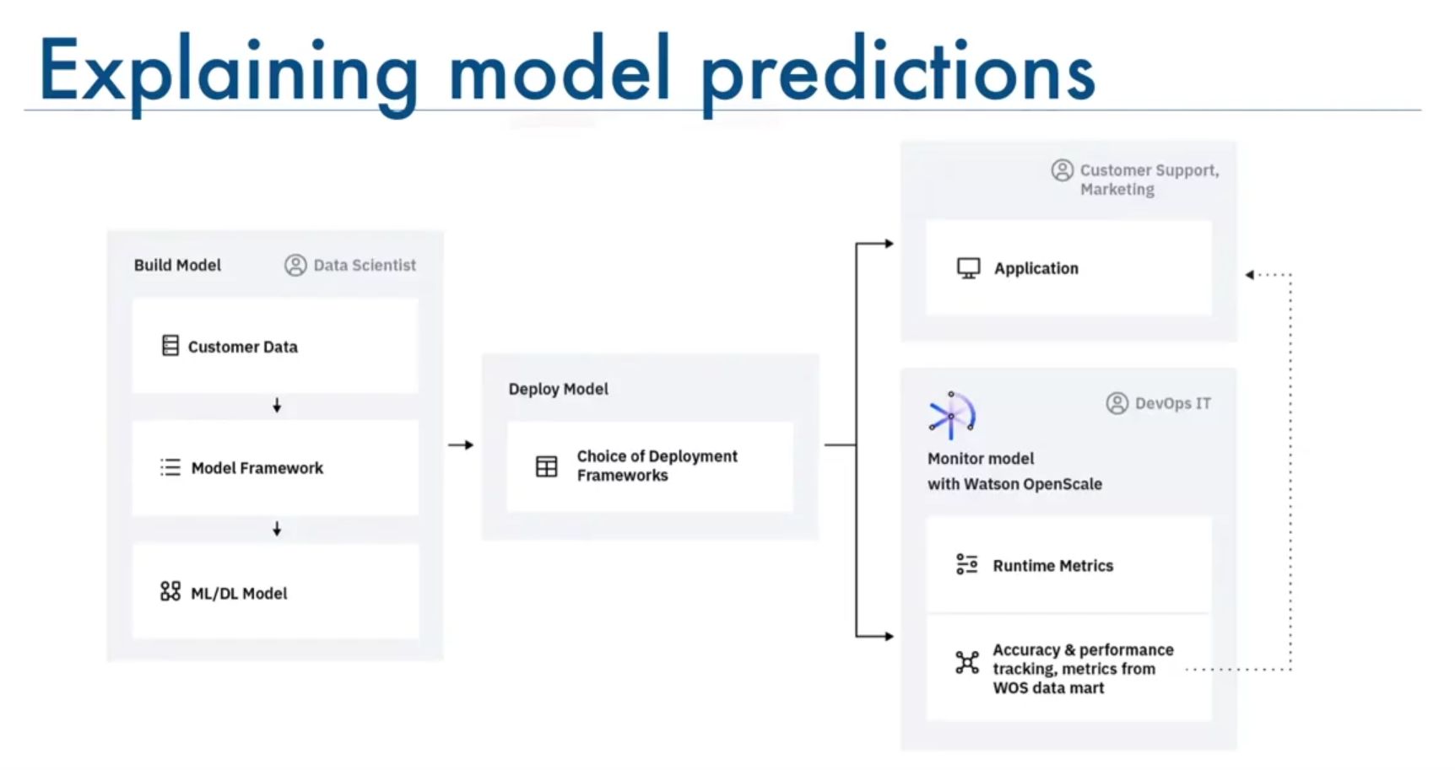

1. **Which products (of those we covered) allow you to build data pipelines using graphical user interface and no coding?**

*IBM SPSS Modeler* and *Modeler Flows* in *Watson Studio*.

1. **Which features of Data Refinery help save hours and days of data preparation?** 
   1. Flexibility of using Intuitive user interface and coding templates enabled with powerful operations to shape and clean data.
   2. Data visualization and profiles to spot the difference and guide data preparation steps.
   3. Incremental snapshots of the results allowing the user to gauge success with each iterative change.
   4. Saving, editing and fixing the steps provide ability to iteratively fix the steps in the flow.
2. **Watson Knowledge Catalog provides what functionality?**

Catalog data and ML assets, help to find relevant assets, keep track of asset lineage, enforce data governance.

1. **PMML, PFA, and ONNX are** open standards for predictive model serialization, exchange, and deployment.
2. **Which node must be used in Modeler flows before any modeling node?**

Type node.

1. **Auto Classification node can be used for data with** a categorical target variable.
2. **Auto Numeric node can be used for data with** a continuous target variable.
3. **IBM SPSS Modeler evolved from which product?**

Clementine.

1. **IBM SPSS Statistics syntax can be created using Graphical user interface of IBM** SPSS Statistics product or syntax editor.
2. **AutoAI provides which of the following services?**

Automatic finding of optimal data preparation steps, model selection, and hyperparameter optimization.

1. **OpenScale provides which of the following services?**

Monitoring for fairness, bias, and model drift.

1. **Predictive Model Markup Language (PMML) was created by which entity?**

The Data Mining Group